**Mandatory hands-on**

**Creating Microservices for account and loan**

**Account**

**AccountController.java**

package com.cognizant.account.controller;

import org.springframework.web.bind.annotation.GetMapping;

import org.springframework.web.bind.annotation.RestController;

@RestController

public class AccountController {

@GetMapping("/account")

public String getAccount() {

return "Account service is up!";

}

}

**AccountApplication.java**

package com.cognizant.account;

import org.springframework.boot.SpringApplication;

import org.springframework.boot.autoconfigure.SpringBootApplication;

*@SpringBootApplication*

public class AccountApplication {

public static void main(String[] args) {

SpringApplication.*run*(AccountApplication.class, args);

}

}

**OUTPUT:**

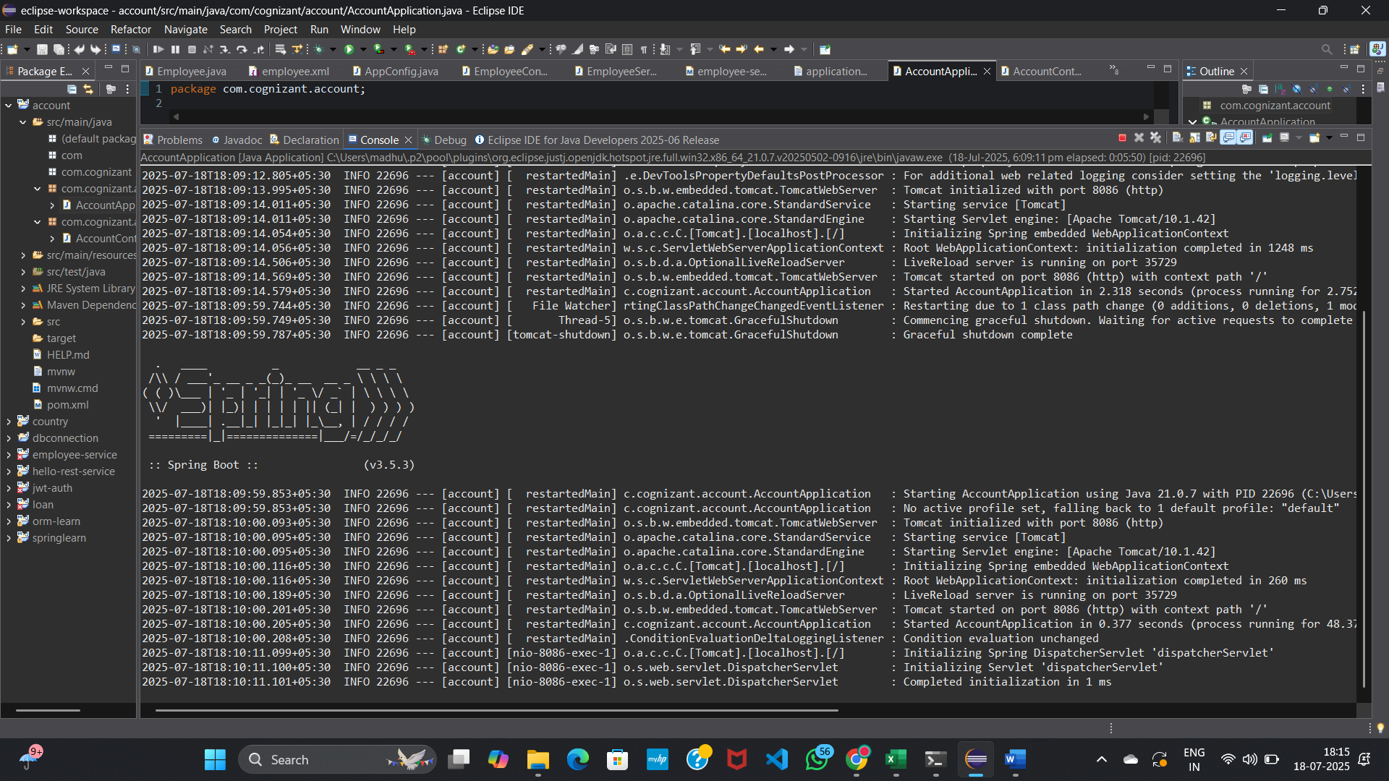

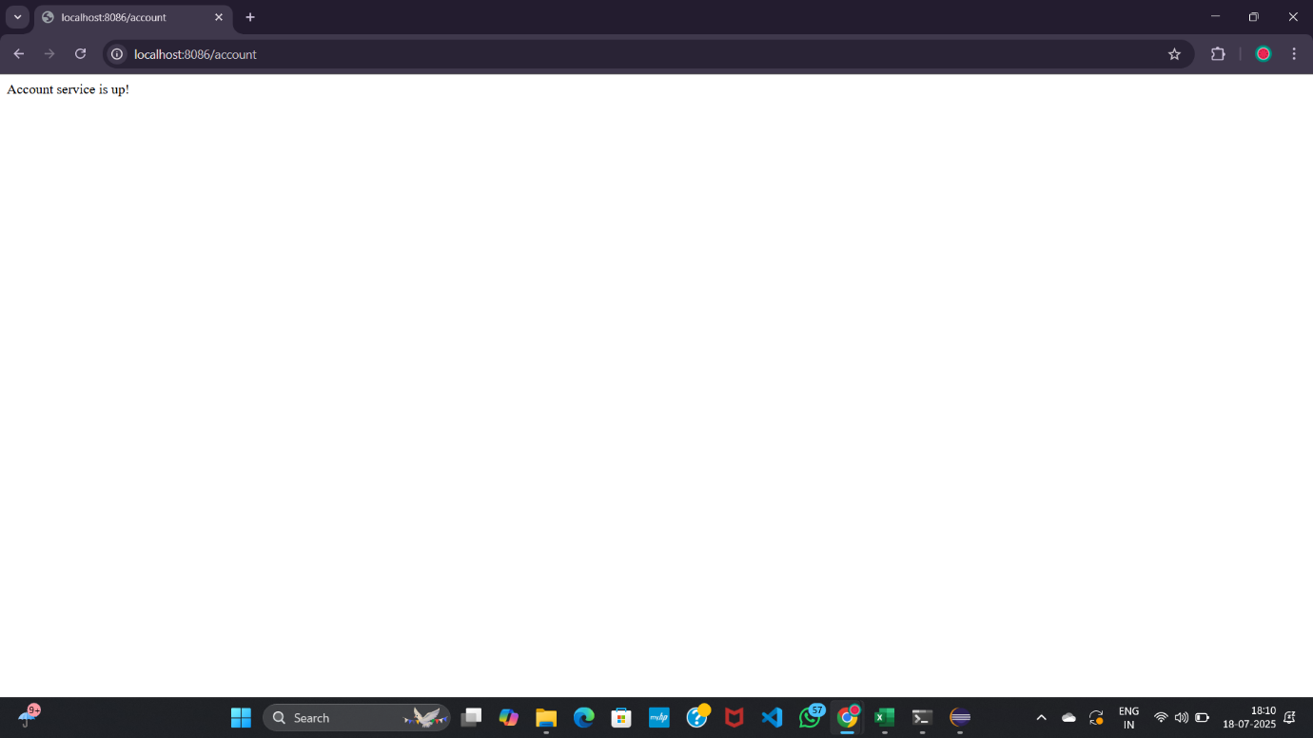

**LoanMicroservices**

**LoanController.java**

package com.cognizant.loan.controller;

import org.springframework.web.bind.annotation.GetMapping;

import org.springframework.web.bind.annotation.RestController;

*@RestController*

public class LoanController {

*@GetMapping*("/loan")

public String getLoanDetails() {

return "Loan service is up!";

}

}

**LoanApplication.java**

package com.cognizant.loan;

import org.springframework.boot.SpringApplication;

import org.springframework.boot.autoconfigure.SpringBootApplication;

@SpringBootApplication

public class LoanApplication {

public static void main(String[] args) {

SpringApplication.run(LoanApplication.class, args);

}}

**OUTPUT:**

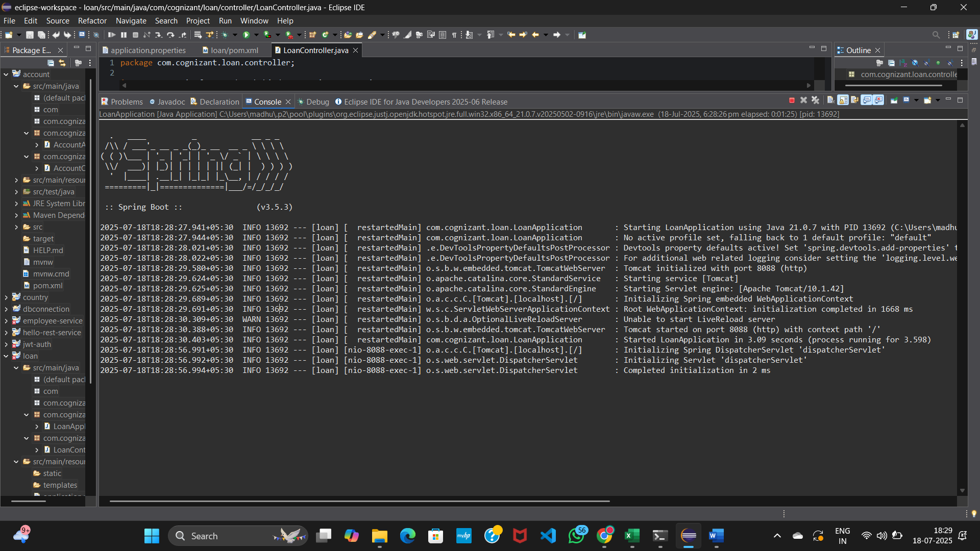

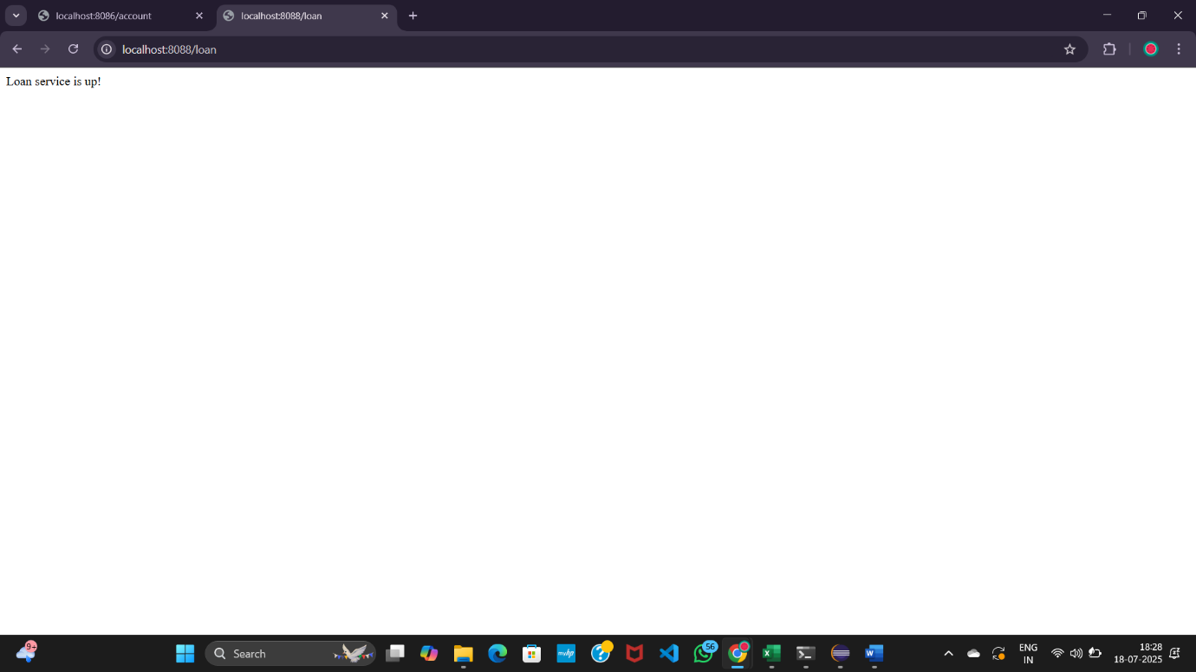

**Create Eureka Discovery Server and register**

**EurekaDiscoveryServerApplication.java**

package com.cognizant.eureka_discovery_server;

import org.springframework.boot.SpringApplication;

import org.springframework.boot.autoconfigure.SpringBootApplication;

import org.springframework.cloud.netflix.eureka.server.EnableEurekaServer;

@SpringBootApplication

@EnableEurekaServer

public class EurekaDiscoveryServerApplication {

public static void main(String[] args) {

SpringApplication.run(EurekaDiscoveryServerApplication.class, args);

}

}

**application.properties**

server.port=8761

spring.application.name=edureka

# Optional: disable self-registration

eureka.client.register-with-eureka=false

eureka.client.fetch-registry=false

**pom.xml**

<dependencies>

<dependency>

<groupId>org.springframework.cloud</groupId>

<artifactId>spring-cloud-starter-netflix-eureka-server</artifactId>

</dependency>

</dependencies>

<dependencyManagement>

<dependencies>

<dependency>

<groupId>org.springframework.cloud</groupId>

<artifactId>spring-cloud-dependencies</artifactId>

<version>2023.0.1</version>

<type>pom</type>

<scope>import</scope>

</dependency>

</dependencies>

</dependencyManagement>

**Register Account and Loan Services as Eureka Clients**

pom.xml → Add Eureka Client Dependency

<dependency>

<groupId>org.springframework.cloud</groupId>

<artifactId>spring-cloud-starter-netflix-eureka-client</artifactId>

</dependency>

**Main Application Class (for both)**

**AccountApplication.java or LoanApplication.java**

package com.cognizant.account; // or loan

import org.springframework.boot.SpringApplication;

import org.springframework.boot.autoconfigure.SpringBootApplication;

import org.springframework.cloud.client.discovery.EnableDiscoveryClient;

@SpringBootApplication

@EnableDiscoveryClient

public class AccountApplication {

public static void main(String[] args) {

SpringApplication.run(AccountApplication.class, args);

}

}

**application.properties (account)**

server.port=8083

spring.application.name=account-service

eureka.client.service-url.defaultZone=http://localhost:8761/eureka

**application.properties(loan)**

server.port=8084

spring.application.name=loan-service

eureka.client.service-url.defaultZone=http://localhost:8761/eureka

**Output:**

